Cathy Huss
Twin Lakes High School
chuss@twinlakes.k12.in.us

I think I found this lab in an ACS publication (Chemunity News?) circa 1993-1994. Otherwise, I do not know the reference or source.

Microrocket Lab - Teacher Notes

I use this lab in Chemistry 1 after balancing equations and before stoichiometry. Students are told they need to find the ratio that makes the best explosion, and aren’t told anything about the relationship between the “right” answer and the balanced equation.

To make gas generators:
Film canisters are harder to find these days, but they’re still available. Stop at Wal-Mart or the pharmacy and ask them to save them for you. Educational Innovation sells them if you can afford to go that route.

1. Cut graduated beral pipets at P and Q as shown. Use the bulb part for collecting the gases (rockets).
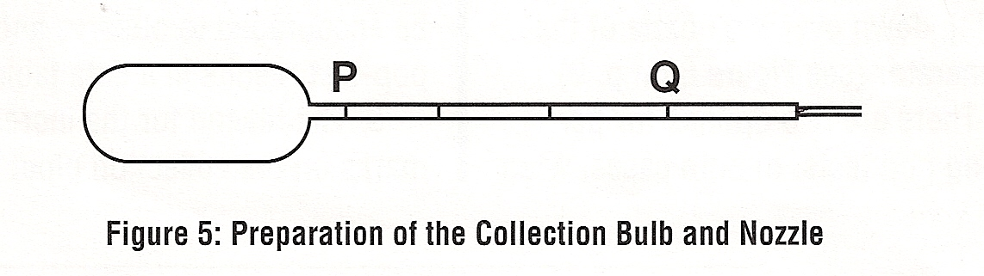
2. Poke hole in lid of film canister. Insert cut off tip into hole. Secure/seal with hot glue gun.

3. I highly recommend labeling the gas generators to help the students remember which reactants go into each generator.

Teaching Tips
1. Demonstrate how to fill the rocket completely with water. My students always have trouble with this.

2. Watch for students having trouble getting their first explosion. There always seems to be one group that can’t get it to work.

3. Common student errors:
- Rocket not divided into 6 equal sections
- Mixing the wrong reactants in the generators (mix H₂O₂ and zinc). Carry some pH paper so you can check their reactions.
- Putting Zn and Mn in generator before ready and then the reaction is over when they’re ready to collect gas (more of a problem with O₂ generation)
- Collect the second gas too long, thus displacing all of the first gas
- Waiting too long between collecting gas mixture and performing the pop test
4. In the past, I’ve used MnO₂ in lieu of Mn. It works but is a lot messier. This will be my first year using solid Mn.

5. Compile the class data and prepare a bar graph for use during post-lab discussions. Following is my class data from last year. The variation in the results in light of the balanced equations is a great opportunity to discuss sources of error.

6. This lab can be messy, including wax all over the lab tables. Have a razor blade scraper handy for cleaning up wax.

Adaptations for ICP Level

1. Demo all steps of the procedure.

2. Mark the rockets for the students since some students have trouble dividing the rocket into 6 equal sections resulting in spurious results.

3. Give the students the data table they need with all the trials and tell them how many times to repeat each run.

4. Have students start with mixtures (4:2 or 3:3) rather than leaving it up to them. That way they’ll have instant success and won’t get frustrated. Once they can do these mixes and get a good pop, have them try all the other ratios.
Microrocket Lab

Hydrogen (H₂) and oxygen (O₂) are two gases that react with each other in a very quick, exothermic reaction. The explosiveness of this reaction is greatest when the hydrogen and oxygen are mixed in the proper ratio. Your task in this experiment is to determine the ratio of the gases that will produce the loudest explosion.

The gases will be collected by a technique called water displacement. The rocket will be completely filled with water and then put over the nozzle of the gas generator. As the gas bubbles into the rocket, water will come out of the rocket. This way, you’ll know how much of each gas is in the rocket. When the desired amount of gas is collected, transfer the bulb to the next gas generator.

Your rocket will be divided into 6 sections. The reason for the marks on the rocket is to help collect different mixtures. For example, if a 5:1 mixture of oxygen to hydrogen is the goal, start collecting oxygen. When the bulb is 5/6ths full, transfer the bulb to the hydrogen generator. This will give you a mixture that is 5 parts oxygen and 1 part hydrogen.

SAFETY
- The two solutions used in this lab, hydrochloric acid and hydrogen peroxide, can cause serious damage if they come in contact with the eye. Safety goggles must be worn at all times.
- Lab aprons are highly recommended!!!
- Wash off any chemicals spilled on skin or clothing with lots of water.
- During pop tests, point bulb away from others. Be careful working around open flames and hot wax.

Materials
Petri dish (2) solid manganese
Micro gas generators (2) solid zinc
Gas collecting bulb = rocket 1.0 M HCl
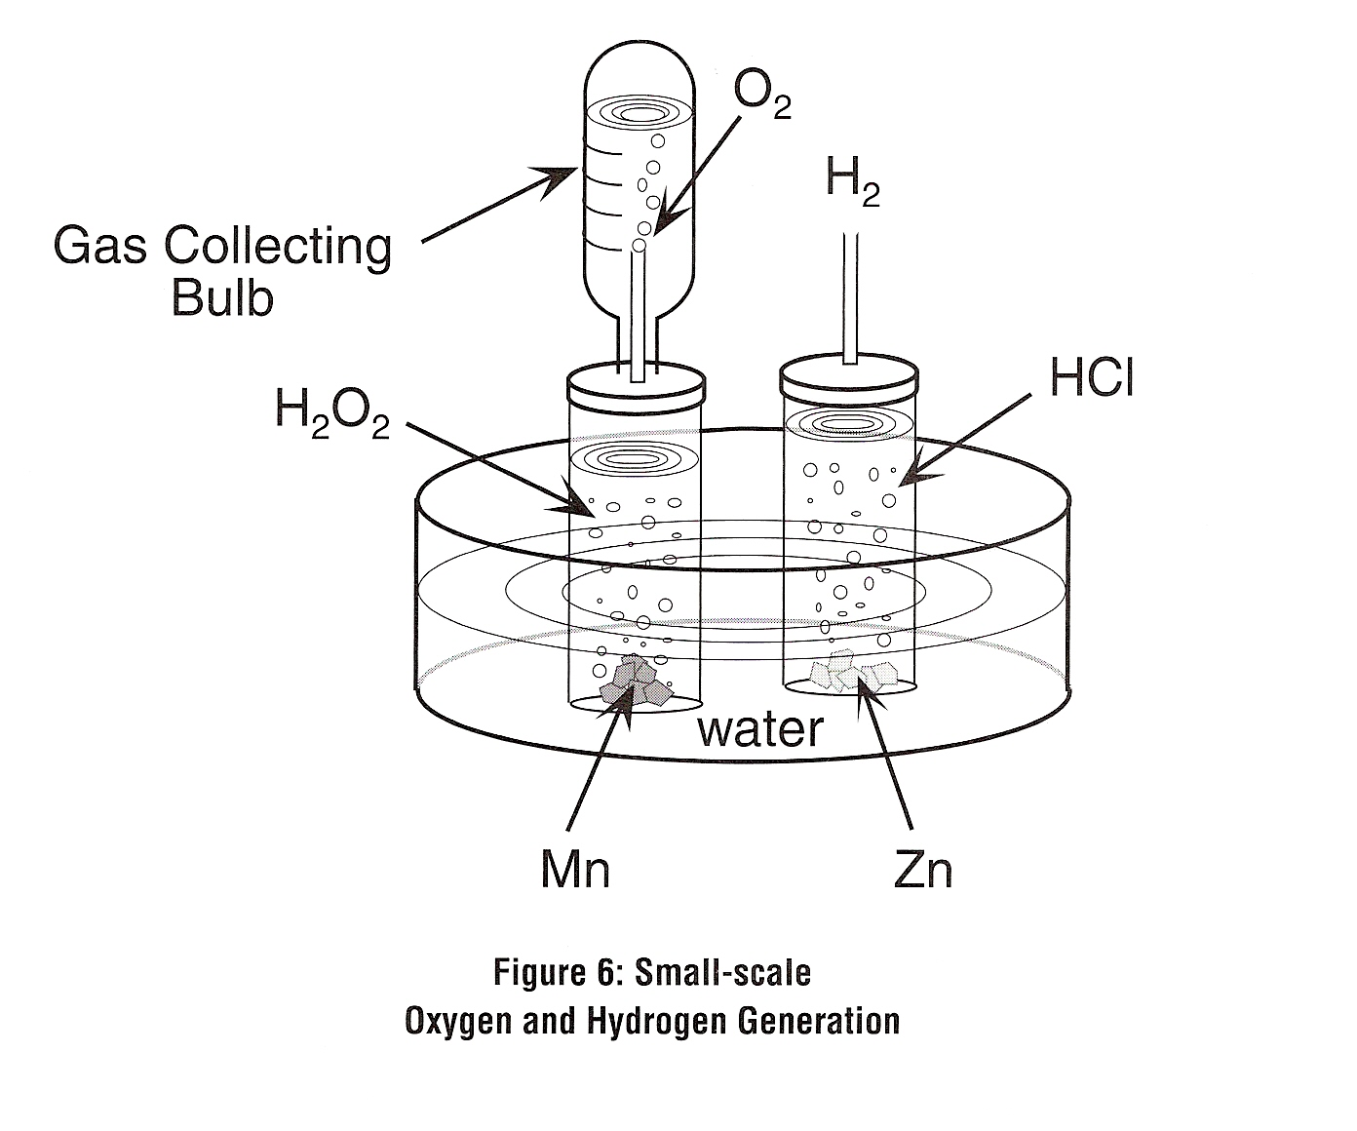
Candle 3% hydrogen peroxide (H₂O₂)
Matches marker
Tape ruler

Procedure
1. Use a ruler to mark 5 evenly spaced lines on the gas collecting bulb (rocket) with a marker. Cover the marks with a piece of tape so they don’t rub off.

2. Fill one of the Petri dishes ¾ full with tap water.

3. Oxygen Generator: Fill the oxygen generator ¾ full with hydrogen peroxide and set the generator in the Petri dish.

4. Hydrogen Generator: Fill the other gas generator ¾ full of 1.0 M hydrochloric acid and set it in the Petri dish.

5. Completely fill the rocket with water from the Petri dish. To fill the gas collection bulb, first squeeze it tightly and then invert it into the water in the Petri dish. Draw up as much water as possible. Then hold the bulb with the mouth pointing up and squeeze out remaining air. Still squeezing the bulb, invert it again into the Petri dish and draw up the remainder of the water needed to fill the bulb. The bulb should be completely full of water

6. Put the candle in the other Petri dish and light the candle.

7. When you’re ready for your first trial, add several pieces of Mn to the oxygen generator, 1 piece of Zn to the hydrogen generator, put on the lids, and start collect gas in the rockets.

8. To perform pop test: Once the bulb is filled with gas, remove it from the nozzle and hold it horizontally with its mouth roughly 1 cm from the flame. Gently squeeze a very small portion of the contents of the bulb into the flame. Record your pop test results in your data table. (Avoid putting the bulb directly into the flame; it will melt.

9. Devise a numerical loudness scale (1 to 5) to rate each pop test. Repeat steps 5 through 8 using different ratios of oxygen and hydrogen gas. You will need to repeat each ratio more than once to be sure your results are reproducible.

10. If bubbling from the gas generators stops or gets really slow, you’ll need to add more of the reactants. The H₂O₂ and HCl will need to be refilled before more metal is needed. Keep using the metal until it is used up.

11. Clean Up: Put any remaining Mn and Zn in the used metal containers. Pour the solutions down the drain.

Pre-Lab Questions
1. In your own words, describe how water displacement is used to collect gases. You may want to include diagrams in your explanation.
2. How many times will you do the pop test?
3. What does it mean to have “reproducible” data?
4. Write the balanced equation for the reaction that occurs in the (1) oxygen generator and in the (2) hydrogen generator. (Hint: the Mn is a catalyst.) Identify the reaction type for each reaction.

Post Lab Questions – Answer these questions on your lab report
1. Write a balanced equation for the pop test reaction. Identify the reaction type.
2. Describe your numerical loudness scale.
3. Which mixture of gases produced the loudest explosion?
4. Compare your ratio in number 4 to the balanced equation for the pop test. What do you notice? Explain.

